Boundary Between Interior and Exterior in Solid Geometry
# Source: AI Source: Provided by: [Data Path: Persons Table -> ID Column: 1, Name_En Column: Motasem Essam] -> From: [ChatGPT] on [7/25/2026]
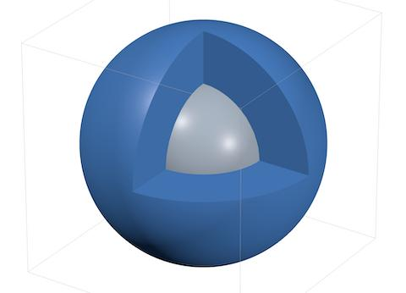
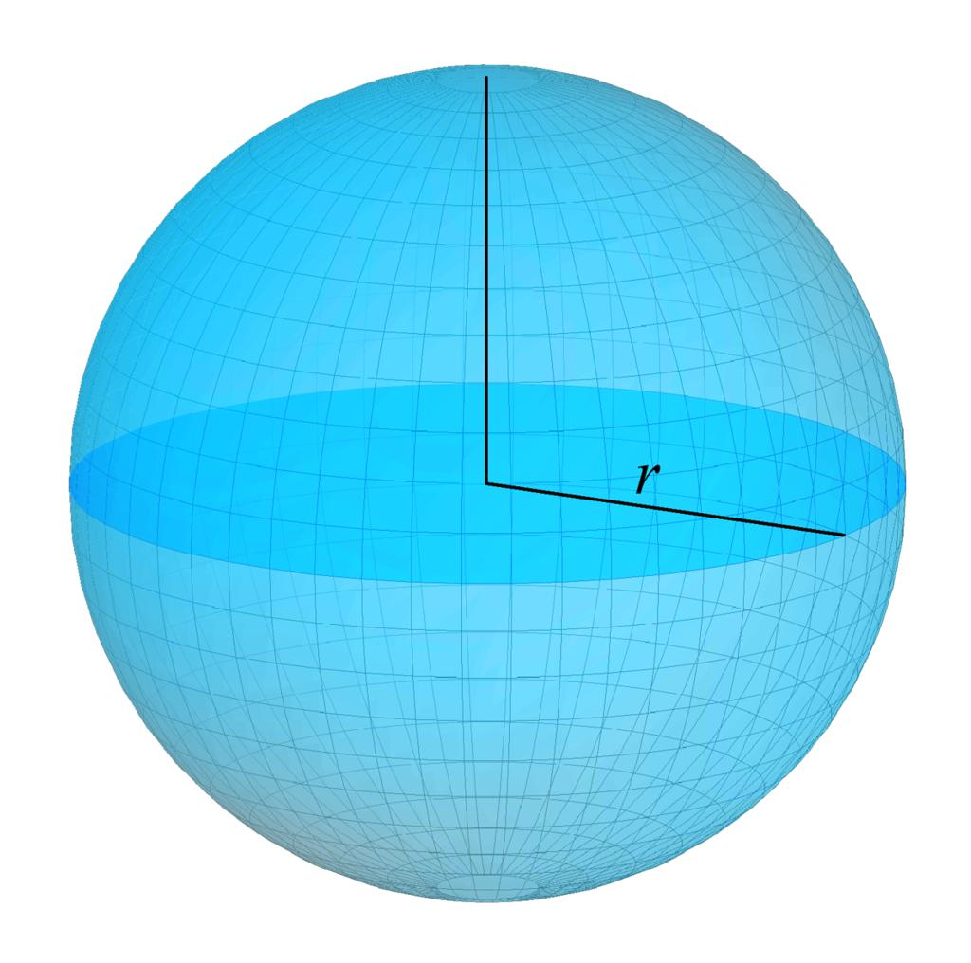
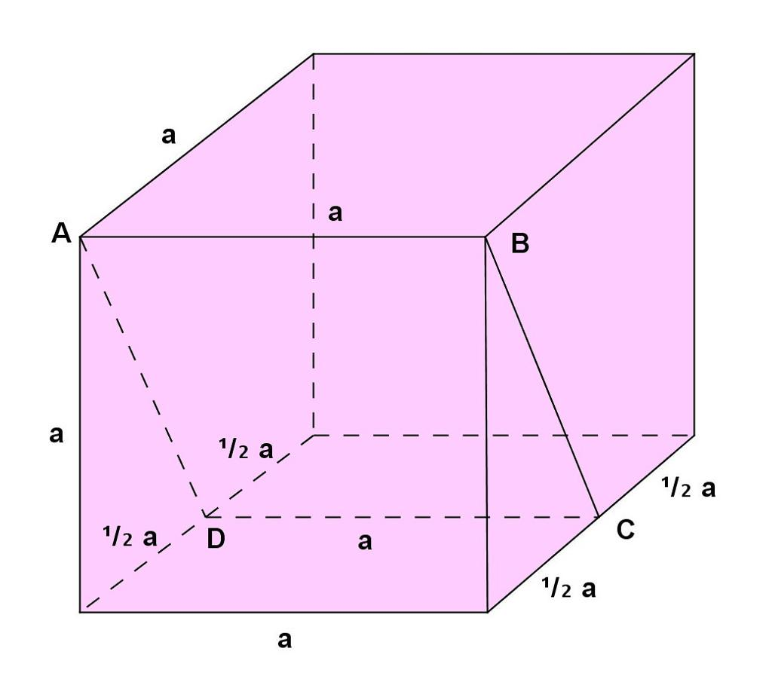

Definition
# Source: AI Source: Provided by: [Data Path: Persons Table -> ID Column: 1, Name_En Column: Motasem Essam] -> From: [ChatGPT] on [7/25/2026]
The boundary between the interior and exterior in solid geometry is the set of points that separates the inside of a three-dimensional region from the space outside it.
The boundary consists of points where every sufficiently small neighborhood contains points belonging to the region and points lying outside it.
For an ordinary solid such as a sphere, the boundary is its outer surface. Points inside the surface belong to the interior, while points outside the surface belong to the exterior.
For example, a solid ball has three distinct parts:
- Interior: the points strictly inside the ball.
- Boundary: the spherical surface enclosing the ball.
- Exterior: the points outside the ball.
The boundary acts as the geometric separator between the interior and exterior.

Simple definition
# Source: AI Source: Provided by: [Data Path: Persons Table -> ID Column: 1, Name_En Column: Motasem Essam] -> From: [ChatGPT] on [7/25/2026]
The boundary between the interior and exterior is the outer dividing surface between the inside of a solid and the space outside it.
For example, the skin of a basketball separates the air inside the ball from the space outside it. In an ideal geometric model, that skin represents the boundary.

3. Classification tree
# Source: AI Source: Provided by: [Data Path: Persons Table -> ID Column: 1, Name_En Column: Motasem Essam] -> From: [ChatGPT] on [7/25/2026]
Types of Boundaries in Solid Geometry
Boundary Between Interior and Exterior
Interior region
Points strictly inside the solid.
Boundary
Points separating the interior from the exterior.
Exterior region
Points outside the solid.
These are three related parts of the spatial classification around a solid, rather than three separate boundary types.

Key characteristics
# Source: AI Source: Provided by: [Data Path: Persons Table -> ID Column: 1, Name_En Column: Motasem Essam] -> From: [ChatGPT] on [7/25/2026]
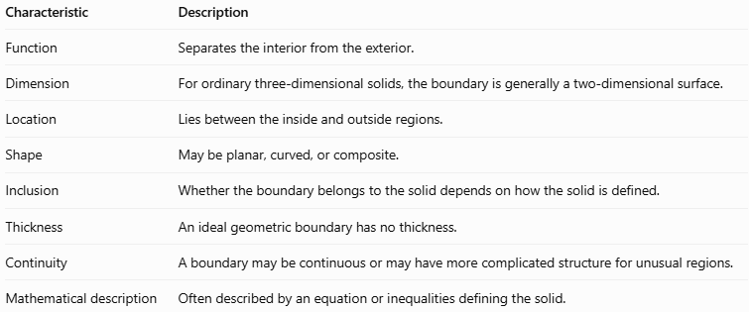
Characteristic | Description
Function | Separates the interior from the exterior.
Dimension | For ordinary three-dimensional solids, the boundary is generally a two-dimensional surface.
Location | Lies between the inside and outside regions.
Shape | May be planar, curved, or composite.
Inclusion | Whether the boundary belongs to the solid depends on how the solid is defined.
Thickness | An ideal geometric boundary has no thickness.
Continuity | A boundary may be continuous or may have more complicated structure for unusual regions.
Mathematical description | Often described by an equation or inequalities defining the solid.

Geometric representation
# Source: AI Source: Provided by: [Data Path: Persons Table -> ID Column: 1, Name_En Column: Motasem Essam] -> From: [ChatGPT] on [7/25/2026]
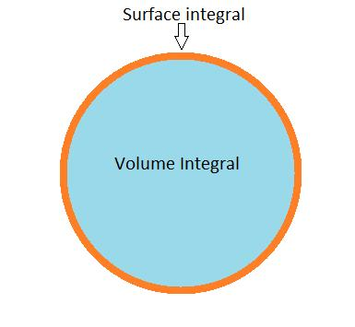
Consider a sphere centered at the origin with radius $r$. Its boundary is the spherical surface.
The three regions can be represented using the distance from the origin.
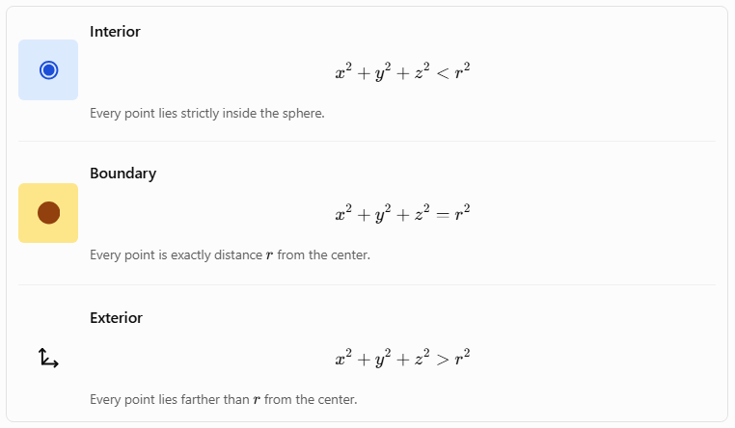
Interior
$$x^{2}+y^{2}+z^{2}<r^{2}$$
Every point lies strictly inside the sphere.
Boundary
$$x^{2}+y^{2}+z^{2}=r^{2}$$
Every point is exactly distance $r$ from the center.
Exterior
$$x^{2}+y^{2}+z^{2}>r^{2}$$
Every point lies farther than $r$ from the center.
The boundary equation uses equality, while the interior and exterior are distinguished by strict inequalities.
Other geometric examples

A. Cube
# Source: AI Source: Provided by: [Data Path: Persons Table -> ID Column: 1, Name_En Column: Motasem Essam] -> From: [ChatGPT] on [7/25/2026]
The six square faces form the boundary of the cube. The interior consists of points within all six faces, and the exterior consists of points outside the cube.
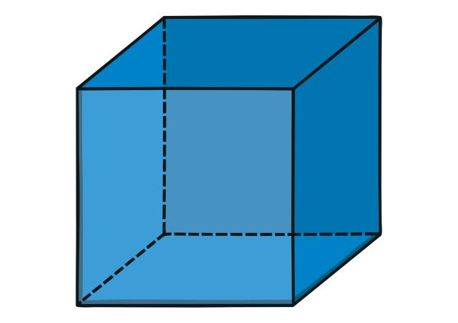

B. Cylinder
# Source: AI Source: Provided by: [Data Path: Persons Table -> ID Column: 1, Name_En Column: Motasem Essam] -> From: [ChatGPT] on [7/25/2026]
The boundary includes the curved lateral surface and two circular end faces. Together, these surfaces separate the cylinder's interior from its exterior.


C. Cone
# Source: AI Source: Provided by: [Data Path: Persons Table -> ID Column: 1, Name_En Column: Motasem Essam] -> From: [ChatGPT] on [7/25/2026]
The curved lateral surface and circular base form the boundary of a solid cone.
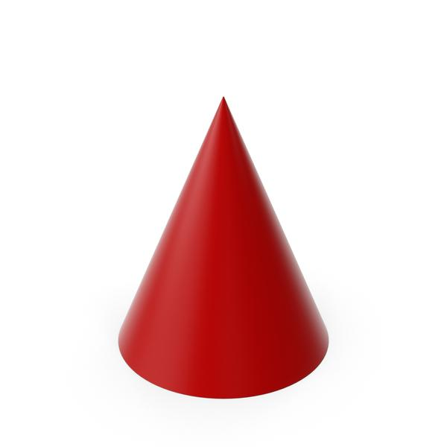

6. Mathematical representations

A. General definition using neighborhoods
# Source: AI Source: Provided by: [Data Path: Persons Table -> ID Column: 1, Name_En Column: Motasem Essam] -> From: [ChatGPT] on [7/25/2026]
Let $S$ be a region in three-dimensional space. A point $p$ is on the boundary of $S$ if every open ball centered at $p$, no matter how small, contains at least one point of $S$ and at least one point outside $S$.
Using the open ball $B_{ε}\left(p\right)$ of radius $ε>0$, this can be expressed as:
$$B_{ε}\left(p\right)∩S≠∅$$
and
$$B_{ε}\left(p\right)∩S^{c}≠∅$$
for every $ε>0$, where $S^{c}$ denotes the complement of $S$.
The set of all such points is called the boundary of $S$, commonly written $∂S$.

B. Boundary of a solid ball
# Source: AI Source: Provided by: [Data Path: Persons Table -> ID Column: 1, Name_En Column: Motasem Essam] -> From: [ChatGPT] on [7/25/2026]
For a closed ball of radius $r$ centered at the origin,
$$S=\left\{\left(x,y,z\right):x^{2}+y^{2}+z^{2}≤r^{2}\right\}$$
its boundary is
$$∂S=\left\{\left(x,y,z\right):x^{2}+y^{2}+z^{2}=r^{2}\right\}.$$
The inequality includes both the interior and the boundary, whereas the equality identifies only the boundary.

C. Boundary of a rectangular solid
# Source: AI Source: Provided by: [Data Path: Persons Table -> ID Column: 1, Name_En Column: Motasem Essam] -> From: [ChatGPT] on [7/25/2026]
Suppose a rectangular solid occupies
$$0≤x≤a, 0≤y≤b, 0≤z≤c.$$
Its boundary consists of the six faces described by:
$$\begin{aligned}x&=0, x=a, \\ y&=0, y=b, \\ z&=0, z=c,\end{aligned}$$
with the other coordinates restricted to their corresponding intervals.
The interior satisfies all six inequalities strictly:
$$0<x<a, 0<y<b, 0<z<c.$$

D. Boundary of a general region defined by a function
# Source: AI Source: Provided by: [Data Path: Persons Table -> ID Column: 1, Name_En Column: Motasem Essam] -> From: [ChatGPT] on [7/25/2026]
If a solid is described by
$$S=\left\{\left(x,y,z\right):f\left(x,y,z\right)≤0\right\},$$
then, under suitable regularity conditions, its boundary is described by
$$f\left(x,y,z\right)=0.$$
For example, the sphere uses $f\left(x,y,z\right)=x^{2}+y^{2}+z^{2}-r^{2}$. However, the equation $f=0$ identifies the boundary only when the function and region are chosen appropriately; it is not a universal rule for every possible region.

Worked examples
# Source: AI Source: Provided by: [Data Path: Persons Table -> ID Column: 1, Name_En Column: Motasem Essam] -> From: [ChatGPT] on [7/25/2026]
Example 1: Identifying the boundary of a sphere
A solid ball has radius $5\text{ cm}$ and center at the origin. Determine whether the point $P=\left(3,4,0\right)$ lies in the interior, on the boundary, or in the exterior.
Step 1: Calculate its distance from the origin.
$$d=\sqrt{3^{2}+4^{2}+0^{2}}=\sqrt{25}=5$$
Step 2: Compare the distance with the radius.
- If $d<5$, the point is inside.
- If $d=5$, the point is on the boundary.
- If $d>5$, the point is outside.
Since $d=5$, the point lies on the boundary.
Answer: $P=\left(3,4,0\right)$ is a boundary point.
Example 2: Classifying three points
Consider a sphere of radius $4$ centered at the origin.
Classify these points:
- $A=\left(1,2,1\right)$
- $B=\left(0,0,4\right)$
- $C=\left(5,0,0\right)$
For each point, compare $x^{2}+y^{2}+z^{2}$ with $4^{2}=16$.
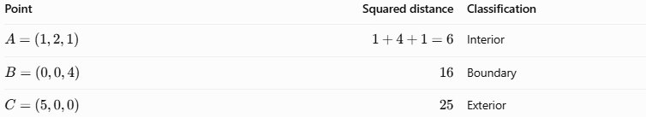
Point | Squared distance | Classification
$$A=\left(1,2,1\right)$$ | $$1+4+1=6$$ | Interior
$$B=\left(0,0,4\right)$$ | $$16$$ | Boundary
$$C=\left(5,0,0\right)$$ | $$25$$ | Exterior
Therefore, $A$ is inside the sphere, $B$ is on its surface, and $C$ is outside it.
Example 3: Boundary of a cube
A cube occupies the region
$$0≤x,y,z≤3.$$
Classify the point $Q=\left(3,1,2\right)$.
The point satisfies all the inequalities defining the cube, but its $x$-coordinate equals $3$, which places it on the face $x=3$.
Answer: $Q$ lies on the boundary, not in the interior.

Comparison with related concepts
# Source: AI Source: Provided by: [Data Path: Persons Table -> ID Column: 1, Name_En Column: Motasem Essam] -> From: [ChatGPT] on [7/25/2026]
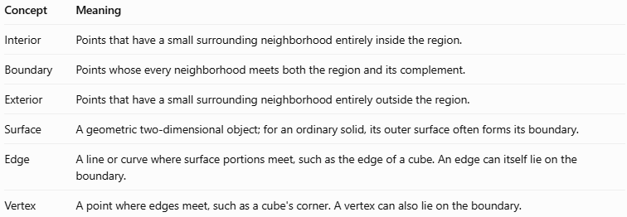
Concept | Meaning
Interior | Points that have a small surrounding neighborhood entirely inside the region.
Boundary | Points whose every neighborhood meets both the region and its complement.
Exterior | Points that have a small surrounding neighborhood entirely outside the region.
Surface | A geometric two-dimensional object; for an ordinary solid, its outer surface often forms its boundary.
Edge | A line or curve where surface portions meet, such as the edge of a cube. An edge can itself lie on the boundary.
Vertex | A point where edges meet, such as a cube's corner. A vertex can also lie on the boundary.
Important distinction: A boundary is not necessarily a smooth surface. It can have corners, edges, disconnected components, or more complicated forms, depending on the region.

Applications
# Source: AI Source: Provided by: [Data Path: Persons Table -> ID Column: 1, Name_En Column: Motasem Essam] -> From: [ChatGPT] on [7/25/2026]
- Architecture: identifying the surfaces that enclose rooms, buildings, and structural components.
- Engineering: defining the outer limits of machine parts and manufactured objects.
- Computer graphics: distinguishing an object's surface from its interior volume and the surrounding scene.
- 3D modeling: defining which points belong to a solid, its surface, or the space outside it.
- Physics: describing the boundary of a volume in which a material or field is present.
- Calculus and topology: defining domains, surface integrals, and properties of spatial regions.

Key points
# Source: AI Source: Provided by: [Data Path: Persons Table -> ID Column: 1, Name_En Column: Motasem Essam] -> From: [ChatGPT] on [7/25/2026]
- The boundary separates the interior of a region from its exterior.
- For a standard solid, the boundary is usually its outer surface.
- A boundary point has arbitrarily small neighborhoods containing both interior-region points and points outside the region.
- The boundary may be included in or excluded from the solid's definition.
- Equations with equality often describe boundaries, while inequalities describe interiors together with or without the boundary.
- Edges and vertices may form parts of a boundary but are not necessarily the whole boundary.

Conclusion
# Source: AI Source: Provided by: [Data Path: Persons Table -> ID Column: 1, Name_En Column: Motasem Essam] -> From: [ChatGPT] on [7/25/2026]
The boundary between the interior and exterior in solid geometry is a fundamental concept used to describe how a three-dimensional region is separated from the surrounding space. By distinguishing interior points, boundary points, and exterior points, we can classify geometric regions precisely and represent their limits using equations, inequalities, and spatial models.

